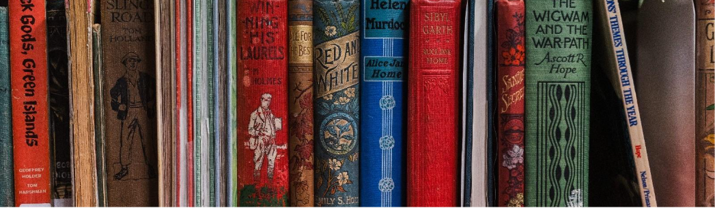
  - 2026 State Library and Archives of Tasmania Fellowship Application

For assistance in completing this form please email fellowshipstatelibrary@libraries.tas.gov.au
Applications are due at 5:00 pm on Friday 6 February 2026.

Personal information

Name

Address

Email

Contact number

Which Fellowship are you applying for?

Choose from Writing, Aboriginal or Research

Project Details

Project Title

Project Description

Provide an overview of your project in 500 words or less

Connection with the State Library and Archives of Tasmania collection

Tell us how your project connects with the State Library and Archives collection in 500 words or less

Output from your project

Describe the anticipated outcome or deliverables of your project in 500 words or less

Benefit to the Tasmanian Community

Explain how your project will positively impact the local community in 300 words or less

Attachments
A brief CV and examples of relevant writing, research and/or projects can be attached to your emailed application.

How to submit your application
Please email all documents to fellowshipstatelibrary@libraries.tas.gov.au

Outcome
Thank you for your State Library and Archives of Tasmania Fellowship application.
You will be advised by email of the outcome of your application before Friday 20 March 2026.

