MONTH YEAR

[Name of sponsored event]
Sponsored by the Sir John Morris Memorial Trust
[Name of recipient and role/organisation]
Table of Contents
About this template – delete this section after reading 3
1 Introduction 3
1.1 Highlights 3
2 Heading level 1 for the main topics 3
2.1 Heading 2 for the sub-topics of the heading 1 3

[Instruction: To update the Table of Contents:
- Select the whole Table of Contents
- Right click on it and select ‘Update field’ from the drop-down menu
- Select update entire table
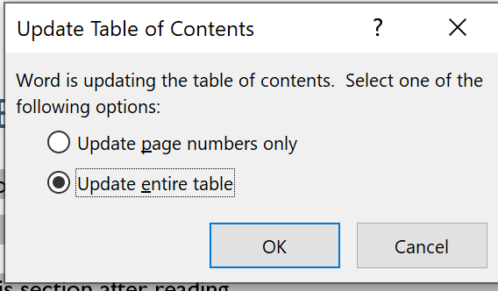

End of instruction – please delete]

About this template – delete this section after reading
This is a longer report. This paragraph is an intro paragraph using the ‘Intro Paragraph’ style.
‘Normal’ is the default body copy style. If you copy and paste any text from another document using the ‘Normal’ paragraph style, it will reformat to this font. Open the styles pane to see the different styles you can use.
- Introduction
  - Highlights
    - Heading 3 for the sub-topics of the heading 2
      - Heading 4 for the sub-topics of the heading 3
Write the content using Normal style
- Links are underlined and use stand out blue colour e.g. Department for Education, Children and Young People
- All the relevant type styles are available from the styles section of the Home tab.
- Use ‘Normal’ type style for Body text (paragraphs).
- Use the headings form Styles: Heading 1 for main topics, Heading 2 for sub-topics and so on. Don’t skip heading level.
- Use a bullet list to show a list of related items. Use a numbered list to show steps in a process.
- Give a link a meaningful name (not bare URL or ‘here’).
- Provide text description for non-text content like images, graphs etc. (select an image > Picture Format menu > Alt Text).
- Avoid text boxes and Word Art as they may be inaccessible to screen readers.
- If you insert a table always define its header. You can use the tables shown below as basis for your own tables. They are also available in the Table Design section.
- Heading level 1 for the main topics
  - Heading 2 for the sub-topics of the heading 1
    - Heading 3 for the sub-topics of the heading 2
      - Heading 4 for the sub-topics of the heading 3
Write the content using Normal style
- Links are underlined and use stand out blue colour e.g. Department for Education, Children and Young People
- All the relevant type styles are available from the styles section of the Home tab.
- Use ‘Normal’ type style for Body text (paragraphs).
- Use the headings form Styles: Heading 1 for main topics, Heading 2 for sub-topics and so on. Don’t skip heading level.
- Use a bullet list to show a list of related items. Use a numbered list to show steps in a process.
- Give a link a meaningful name (not bare URL or ‘here’).
- Provide text description for non-text content like images, graphs etc. (select an image > Picture Format menu > Alt Text).
- Avoid text boxes and Word Art as they may be inaccessible to screen readers.
- If you insert a table always define its header. You can use the tables shown below as basis for your own tables. They are also available in the Table Design section.

