The event title  Add a brief description of the event here.  Date:  Time: | 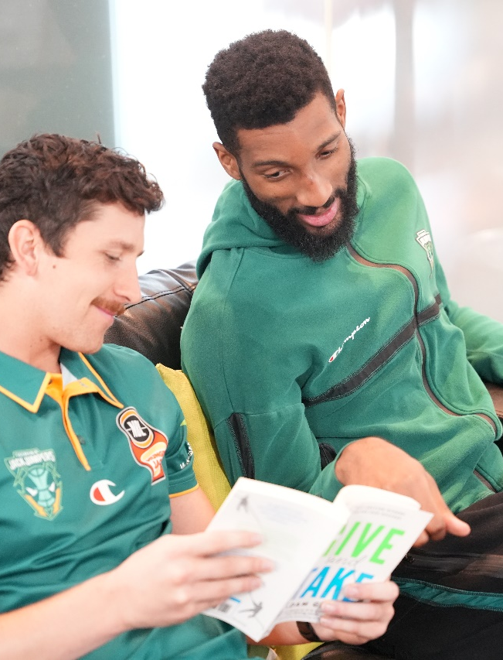  Figure 1jack Jumpers enjoys reading

